AIN SHAMS UNIVERSITY

FACULTY OF ENGINEERING
CSE 242/232: Advanced Software Engineering – Fall 2025

Software Requirement Specification (SRS)
Travel Booking System
Tripzy

Omar Mohamed Khamis Zaky | 24P0117
Fahd Khaled Khataan | 24P0073
Ziad Amr Mohamed | 24P0062
Amira Botros Enaam | 24P0284
Sarah Osama Hassan | 24P0054
Hannah Hassan Ahmed | 24P0089
Mohamed Osama Mohamed | 24P0235
Mohamed Kareem Kamal | 24P0047
Noreen Mohamed Tawfik | 24P0147
Rawan Mohammad Amin Mokhtar | 24P0148

Contents
AIN SHAMS UNIVERSITY 1
FACULTY OF ENGINEERING 1
1. Introduction 1
1.1 Purpose 1
1.2 List of Definitions 1
1.3 Scope 2
1.4 List of References 2
1.5 Overview 2
2. General Description 3
2.1 Product Perspective Tripzy 3
2.2 General Capabilities 3
2.3 General Constraints 4
2.4 User Characteristics 4
2.5 Environment Description 5
2.6 Assumptions and Dependencies 5
3. Specific Requirements 6
3.1 Capability Requirements 6
3.1.1 User Management and Authentication 6
3.1.2 Data Acquisition (Scraping) 6
3.1.3 Search and Discovery 6
3.1.4 Reservation and Transaction 6
3.1.5 Administrative Functions 7
3.2 Constraint Requirements 7
3.2.1 Technical Constraints 7
3.2.2 Operational Constraints 7
3.2.3 Interface Constraints 7
4. Use Case Diagram 8
4.1 Diagram 8
4.2 Narrative Description 9
4.2.1 Sign up 9
4.2.2 Update Profile 10
4.2.3 Login 11
4.2.4 Book Service (Parent) 12
4.2.5 Book Hotel 13
4.2.6 Book Flight 14
4.2.7 Rent Car 15
4.2.8 Reserve Property 16
4.2.9 Review Reservation Request (Included) 17
4.2.10 Make Payment 18
4.2.11 Validate Payment 19
4.6.12 View Booking 20
4.2.13 Modify Booking 21
4.2.14 Modify Hotel 22
4.2.15 Modify Flight 23
4.2.16 Modify Car Rent 24
4.2.17 Modify Property Reservation 25
4.2.18 Review Booking 26
4.2.19 Forget Password 27
4.2.20 Manage User 28
4.2.21 Manage Booking 29
4.2.22 View Reports 30
4.2.23 Add Property 31
4.2.24 Review Property Add Request (Included) 32
4.2.25 Delete Property 33
5. Swimlane Diagram (Per Use Case) 35
5.1 xx 35
5.2 xx 35
6. Sequence Diagram (Per Major Scenario) 36
6.1 xx 36
6.2 xx 36
7. Noun Extraction & CRC Cards 37
7.1 Noun Extraction 37
7.1.1 List of all nouns 37
7.1.2 List of excluded nouns 37
7.1.3 List of candidate classes 38
7.2 Initial Class Diagram 39
7.3 CRC Cards 40
8. State Diagram 41
9. Client-Object Relation Diagram 42
10. Class Diagram 43
11. Architectural Model 44
12. Component Diagram 45
13. Project Estimated Cost 46
14. Time Plan 47
15. References 48
16. Appendices 49

1. Introduction
1.1 Purpose
The purpose of this document is to present a detailed description of the Tripzy Travel Booking System. It will explain the purpose and features of the system, the interfaces of the system, what the system will do, and the constraints under which it must operate. This document is intended for the stakeholders of the project, including the project supervisors and the development team, to ensure a shared understanding of the deliverables and technical specifications.
1.2 List of Definitions
The following terms, acronyms, and abbreviations are used throughout this document:
- SRS: Software Requirements Specification.
- Tripzy: The name of the software product described in this document.
- API (Application Programming Interface): A set of functions and procedures allowing the creation of applications that access the features or data of an operating system, application, or other service.
- Scraper (Web Scraper): An automated software module used to extract data (inventory) from external websites.
- Gateway (Payment Gateway): An external service (e.g., Stripe) that processes credit card payments for e-commerce sites.
- Auth Provider: An external service (e.g., Firebase, Auth0) used to manage user identities and secure login sessions.
- LMS: Learning Management System.
- GUI: Graphical User Interface.
- Transaction Token: A unique security string returned by the Payment Gateway to verify a successful payment without storing sensitive credit card data.
- Availability: The current stock status of a specific Hotel Room or Flight seat.

1.3 Scope
The software product to be produced is a Travel Booking System named Tripzy.
- Functionality: Tripzy allows users to search for hotels and flights, view detailed information, and book combined travel packages. It simplifies the reservation process by aggregating accommodation and transportation into a single workflow.
- Architecture: The system utilizes a hybrid approach. It relies on a local database populated by a Web Scraper for inventory management, ensuring fast search results. For security-critical operations, it integrates with third-party APIs for user authentication and payment processing.
- Benefits: This system provides a realistic simulation of a booking platform, handling concurrency (preventing double-booking), managing state changes (Pending to Confirmed), and generating statistical reports for administrators.

1.4 List of References
- I. Sommerville, Software Engineering, 10th ed. Pearson, 2015.
- [Insert the specific Java/Python documentation or libraries you used, e.g., "Jsoup HTML Parser," or "Stripe API Documentation"].
1.5 Overview
The remainder of this document is organized as follows:
- Section 2 provides a general description of the system, including user characteristics and product perspective.
- Section 3 details the specific requirements, including capabilities and constraints.
- Sections 4-6 present the behavioral models of the system using Use-Case, Swimlane, and Interaction diagrams.
- Sections 7-10 cover the object-oriented analysis, including Noun Extraction, CRC cards, and Class diagrams.
- Sections 11-12 detail the architectural and component design.
- Sections 13-14 provide the project management details, including cost estimation and time planning.

2. General Description
2.1 Product Perspective Tripzy
is a standalone software system designed to operate within a distributed computing environment. It functions as a comprehensive travel booking platform that bridges the gap between static inventory and dynamic service integration. Unlike self-contained systems, Tripzy adopts a hybrid architectural approach:
- Data Acquisition Layer: It interfaces with a custom WebScraper module to populate a local Database with realistic Hotel and Flight inventory from external sources.
- Service Integration Layer: It communicates with external APIs (Application Programming Interfaces) to handle Authentication and PaymentProcessing, ensuring that security-critical operations are offloaded to specialized providers. This modular design ensures that the core reservation logic is decoupled from data sources and security protocols, allowing for easier maintenance and scalability.
2.2 General Capabilities
The primary capability of the system is the management of the Reservation lifecycle. The system provides the following core functions:
- Inventory Discovery: The system allows a Customer to perform a Search based on criteria such as Destination, CheckInDate, and CheckOutDate. It filters the local database to display available Hotels.
- Package Customization: Users can select specific Room types and optionally bundle transportation add-ons, specifically Flights and CarRentals, into a single booking package.
- Transaction Processing: The system calculates the TotalBill and securely processes the transaction via a PaymentGateway. It handles the transition of a Reservation from a "Pending" state to a "Confirmed" state upon successful payment.
- Administrative Oversight: An Admin dashboard provides visualization of system Statistics, such as total revenue and booking volume, and allows the triggering of data refresh cycles via the WebScraper.

2.3 General Constraints
The design and implementation of Tripzy are subject to the following constraints:
- Network Connectivity: The system requires an active internet connection to communicate with the AuthenticationProvider and PaymentGateway, as well as to perform web scraping operations.
- Data Latency: Since inventory data is scraped periodically rather than in real-time, there is a minor latency constraint where the local database might not reflect the exact second-by-second availability of the source website.
- Educational Scope: The project is limited by a fixed deadline (December 20th), necessitating the use of "Test Mode" environments for payments rather than live banking transactions.
2.4 User Characteristics
The system is designed for two distinct user classes:
- Customer: This user is expected to have basic computer literacy and familiarity with standard e-commerce workflows (searching, cart management, and online payment). No technical training is required.
- Admin: This user is expected to have a higher level of technical proficiency. They must understand the implications of triggering the WebScraper and interpreting system logs and Statistics.

2.5 Environment Description
The operational environment for Tripzy includes:
- Client Side: The application is designed to run on standard personal computers (Windows/macOS/Linux) capable of supporting the Java Runtime Environment (JRE) or a modern Web Browser (depending on final UI choice).
- Server/Database Side: The system relies on a Relational Database Management System (RDBMS), such as MySQL or PostgreSQL, to store relational data for Users, Reservations, and Inventory.
- External Interfaces: The system operates within an environment that permits outbound HTTP/HTTPS requests to third-party API endpoints.
2.6 Assumptions and Dependencies
The requirements specified in this document are based on the following assumptions:
- Scraping Stability: It is assumed that the HTML structure of the target travel websites used by the WebScraper will not change drastically during the development phase.
- API Availability: It is assumed that the Firebase (Authentication) and Stripe (Payment) sandbox environments will remain operational and accessible.
- Data Integrity: It is assumed that the data extracted by the scraper contains valid formats for dates and prices.
- Dependency: The system implementation depends on the availability of specific software libraries (e.g., Jsoup for parsing, JDBC for database connectivity).

3. Specific Requirements
3.1 Capability Requirements
This section itemizes the functional features that the Tripzy system must provide to its users.

3.1.1 User Management and Authentication
- REQ-1: The system allow users to register for a new account using an email and password.
- REQ-2: The system shall authenticate users via a secure Third-Party Authentication Provider (e.g., Firebase Auth).
- REQ-3: The system shall maintain distinct sessions for two user roles: Customer and Admin.
- REQ-4: The system shall allow Customers to view and edit their profile information.

3.1.2 Data Acquisition (Scraping)
- REQ-5: The system shall include a WebScraper module capable of parsing external HTML sources to extract hotel and flight data.
- REQ-6: The system shall sanitize and store the extracted inventory data (Hotel Name, Location, Room Rate, Airline, Schedule) into the local relational database.
- REQ-7: The system shall allow the Admin to trigger the scraping process manually via the dashboard.

3.1.3 Search and Discovery
- REQ-8: The system shall provide a search interface where Customers input a Destination, Check-in Date, and Check-out Date.
- REQ-9: The system shall filter results to show only Hotels that have available Rooms for the specified date range.
- REQ-10: The system shall display detailed information for each Hotel, including amenities, star rating, and room types.

3.1.4 Reservation and Transaction
- REQ-11: The system shall allow Customers to select a specific Room type (e.g., Single, Double, Suite) during the booking process.
- REQ-12: The system shall offer the option to add a Flight or Car Rental to the current reservation package.
- REQ-13: The system shall calculate the Total Bill by aggregating the costs of the Room (multiplied by nights) and any selected add-ons.
- REQ-14: The system shall interface with an external Payment Gateway (e.g., Stripe) to process credit card transactions securely.

- REQ-15: The system shall generate a digital Receipt and update the Reservation status to "Confirmed" only upon receiving a successful transaction token.
- REQ-16: The system shall allow Customers to Cancel an existing reservation, which triggers a status update and restores the inventory availability.

3.1.5 Administrative Functions
- REQ-17: The system shall provide an Admin Dashboard that displays Statistics, including total bookings made and total revenue generated.
- REQ-18: The system shall allow the Admin to view a log of scraping activities and system errors.
3.2 Constraint Requirements
This section specifies the restrictions and constraints imposed on the system's design and implementation.

3.2.1 Technical Constraints
- CON-1: The system must utilize an Object-Oriented Programming language (Java/C# or similar) for the core logic.
- CON-2: The system must use a Relational Database (MySQL/PostgreSQL) for data persistence.
- CON-3: All external API keys (for Auth and Payment) must not be hardcoded in the source files but stored in secure configuration files.

3.2.2 Operational Constraints
- CON-4: The system must prevent Double-Booking (Concurrency Control). If two users attempt to book the last available room simultaneously, the system must process only the first request and inform the second user that the room is no longer available.
- CON-5: The Web Scraper module must be executed only when the system load is low to prevent database locking performance issues.

3.2.3 Interface Constraints
- CON-6: The User Interface must be responsive and accessible on standard desktop resolutions (1920x1080 and 1366x768).
- CON-7: All currency values must be displayed with two decimal precision.

4. Use Case Diagram

4.1 Diagram
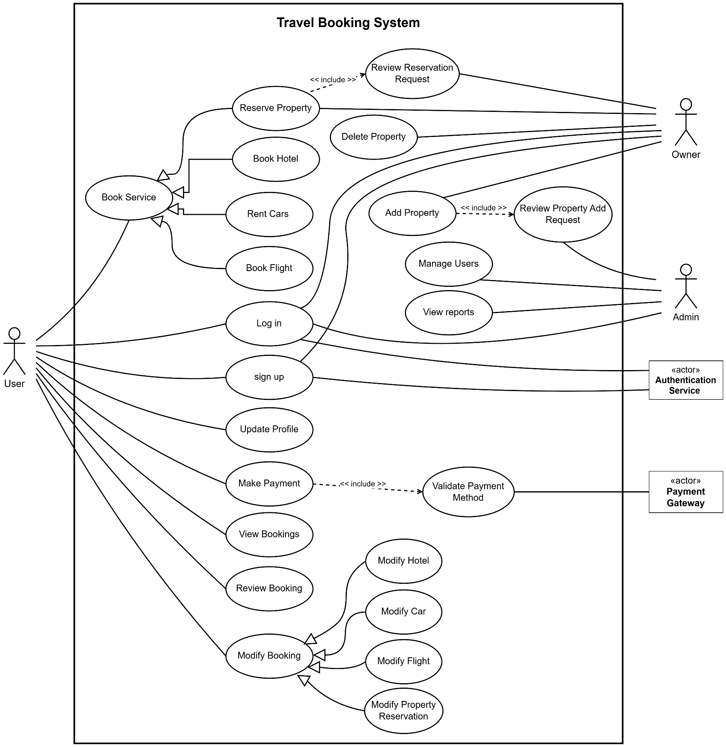

4.2 Narrative Description

4.2.1 Sign up
Field | Description
Use case name | Signup
Related Requirements | Requirement A.1
Goal In Context | A person wants to register a new account (User, Owner, or Admin) to access the system.
Preconditions | - Person is not logged in.  - System is online.  - Person has a valid email address.
Successful End Condition | A new account is created with the selected role, and user is logged into the system.
Failed End Condition | Account creation fails due to duplicate email or network error
Primary Actors | User, Owner
Secondary Actors | Authentication Service
Trigger | Actor clicks "Sign Up" button.
Main Flow | Step Action  1 System prompts for email, password, and Role Selection (User or Owner).  2 Actor enters the required personal details.  3 System transmits data to Authentication Service.  4 Authentication Service validates uniqueness and creates credentials.  5 System creates the local profile and logs the Actor in.
Extensions | Step Branching Action  4.1 Authentication Service reports email already exists.  4.2 System displays "Account already exists" error.

4.2.2 Update Profile
Field | Description
Use case name | Update Profile
Related Requirements | Requirement A.4
Goal In Context | A registered account holder (User or Owner) wants to update their personal information.
Preconditions | Actor is logged in.
Successful End Condition | Profile details are updated in the database.
Failed End Condition | Update is discarded due to invalid input or network error.
Primary Actors | User, Owner
Secondary Actors | None
Trigger | Actor clicks "Edit Profile" on their dashboard.
Main Flow | Step Action  1 Actor navigates to the "My Profile" section.  2 System displays current personal details in editable form.  3 Actor modifies the desired fields.  4 Actor clicks "Save Changes".  5 System validates input format (e.g., phone number digits).  6 System updates the database record and confirms success.  7 System refreshes the profile view with updated data.
Extensions | Step Branching Action  5.1 System detects invalid format entered.  5.2 System shows validation error and highlights the invalid field.

4.2.3 Login
Field | Description
Use case name | Log in
Related Requirements | Requirement A.2, Requirement A.3
Goal In Context | Actor wants to authenticate identity to access their role-specific dashboard.
Preconditions | Actor has a registered account.
Successful End Condition | Actor is authenticated and redirected to the correct home screen.
Failed End Condition | Login denied; user remains unauthenticated with appropriate error feedback.
Primary Actors | User, Owner, Admin
Secondary Actors | Authentication Service
Trigger | Actor clicks the "Log in" button.
Main Flow | Step Action  1 System displays login form with fields: Email and Password  2 Actor enters registered email and password.  3 Actor clicks "Submit".  4 System transmits credentials to Authentication Service.  5 System identifies the Actor's role (User/Owner/Admin).  6 System grants access to the role-specific dashboard.
Extensions | Step Branching Action  1.1 Actor clicks "Forgot Password?" instead of entering credentials.  1.2 System initiates the password reset workflow.  3.1 Invalid Credentials.  3.2 System displays "Invalid email or password."

4.2.4 Book Service (Parent)
Field | Description
Use case name | Book Service
Related Requirements | Requirement A.8
Goal In Context | User wants to reserve a service (Abstract Base Use Case).
Preconditions | User is logged in.
Successful End Condition | Service is added to the booking package or requested.
Failed End Condition | Service is unavailable; no reservation is created.
Primary Actors | User
Secondary Actors | Payment Gateway
Trigger | User navigates to booking section or initiates service search.
Main Flow | Step Action  1 User searches for service availability.  2 System displays available options.  3 User selects a specific option.  4 System processes the reservation request.
Extensions | Step Branching Action  2.1 No services found matching criteria.  2.2 System displays "No results found".

4.2.5 Book Hotel
Field | Description
Use case name | Book Hotel
Related Requirements | Requirement A.9, Requirement A.11
Goal In Context | The user wants to find, select, and reserve a specific hotel room for specified dates.
Preconditions | User is logged in.
Successful End Condition | Hotel room is successfully booked, confirmed, and added to user's itinerary with payment processed.
Failed End Condition | Selected room type is out of stock; no reservation is created.
Primary Actors | User
Base Use Cases | Book Service
Trigger | User navigates to booking hotels section.
Main Flow | Step Action  1 User searches for hotel availability by specifying Destination, Check-in, Check-out dates, Number of guests, and Number of rooms needed.  2 System displays available hotels with star ratings and prices.  3 User selects a specific Hotel.  4 System displays hotel details and available room Types (e.g., Single, Double, Suite).  5 User selects a specific Room Type.  6 System verifies that the selected room is still available.  7 System calculates total cost.  8 System adds the Hotel Room to the pending reservation package.
Extensions | Step Branching Action  6.1 Selected Room Type is sold out.  6.2 System suggests alternative room types.

4.2.6 Book Flight
Field | Description
Use case name | Book Flight
Related Requirements | Requirement A.5, Requirement A.12
Goal In Context | The user wants to reserve a flight seat for their trip.
Preconditions | User is logged in.
Successful End Condition | A flight ticket is added to the reservation package.
Failed End Condition | Selected flight is fully booked.
Primary Actors | User
Base Use Cases | Book Service
Trigger | User navigates to booking flights section.
Main Flow | Step Action  1 User searches for Flight availability by specifying Origin, Destination, and Travel Date.  2 System displays available flights with Airlines and Departure Times.  3 User selects a specific Flight.  4 System displays available Seat Classes (e.g., Economy, Business).  5 User selects a specific Seat Class.  6 System verifies that the seat is still available.  7 System adds the Flight Ticket to the pending reservation package.
Extensions | Step Branching Action  6.1 Selected Flight is fully booked.  6.2 System displays "Join Waitlist" option.

4.2.7 Rent Car
Field | Description
Use case name | Rent Cars
Related Requirements | Requirement A.12
Goal In Context | Customer wants to add a vehicle rental to their pending trip package.
Preconditions | Customer has started a reservation process.
Successful End Condition | Car rental is added to the pending reservation.
Failed End Condition | No cars available for selected dates.
Primary Actors | User
Base Use Cases | Book Service
Trigger | User navigates to renting cars section.
Main Flow | Step Action  1 User searches for Cars by Pickup Location and Dates.  2 System lists available car models and daily rates.  3 User selects a specific car model.  4 System verifies vehicle availability for the requested period.  5 System adds the Car Rental to the pending reservation package.
Extensions | Step Branching Action  4.1 Selected car model is no longer available.  4.2 System suggests similar vehicle classes.

4.2.8 Reserve Property
Field | Description
Use case name | Reserve Property
Related Requirements | Requirement A.20
Goal In Context | User wants to book a vacation rental property, subject to Owner approval.
Preconditions | User is logged in.
Successful End Condition | Reservation request is sent to the Owner.
Failed End Condition | Property is blocked or Owner declines.
Primary Actors | User
Secondary Actors | None
Included Cases | Review Reservation Request
Base Use Cases | Book Service
Trigger | User navigates reserve property section.
Main Flow | Step Action  1 User searches for Property by location and dates.  2 System displays available listings (Apartments, Villas).  3 User selects a Property and clicks "Request to Book".  4 System sets reservation status to "Pending Approval".  include::Review Reservation Request.  5 System notifies User of the final decision (Approved/Declined).

4.2.9 Review Reservation Request (Included)
Field | Description
Use case name | Review Reservation Request
Related Requirements | Requirement A.25
Goal In Context | Owner reviews a booking request before confirming it.
Preconditions | A reservation request is made by a User.
Successful End Condition | Request is Approved or Declined.
Primary Actors | Owner
Secondary Actors | None
Trigger | Invoked by "Reserve Property" use case.
Main Flow | Step Action  1 Owner receives notification of new request.  2 Owner views requester profile and requested dates.  3 Owner approves or declines the request.  4 System updates reservation status accordingly.

4.2.10 Make Payment
Field | Description
Use case name | Make Payment
Related Requirements | Requirement A.14, Requirement A.15
Goal In Context | User completes the purchase of their reservation.
Preconditions | Reservation is in "Pending" state with items selected.
Successful End Condition | Transaction successful; Reservation status updates to "Confirmed".
Failed End Condition | Transaction declined; Reservation remains Pending.
Primary Actors | User
Secondary Actors | Payment Gateway
Trigger | User clicks "Checkout".
Included Cases | Validate Payment Method
Main Flow | Step Action  1 System displays Total Bill summary.  2 User enters payment details (Card Number, CVV, Expiry).  include::Validate Payment Method.  3 System sends charge request to Payment Gateway.  4 Payment Gateway processes transaction and returns success token.  5 System issues receipt and changes status to "Confirmed".
Extensions | Step Branching Action  3.1 Validation failed (Invalid format).  3.2 System asks user to correct details.  5.1 Payment Gateway declines payment (Insufficient funds).  5.2 System displays "Transaction Failed".

4.2.11 Validate Payment
Field | Description
Use case name | Validate Payment Method
Related Requirements | Requirement A.14
Goal In Context | Ensure payment data is valid before sending to gateway.
Preconditions | User has entered payment details.
Successful End Condition | Payment data is deemed valid.
Failed End Condition | Data is flagged as invalid.
Primary Actors | Payment Gateway
Secondary Actors | None
Trigger | Invoked by "Make Payment" use case.
Main Flow | Step Action  1 System receives payment method data (Card number, expiration date, CVV, Cardholder name)  2 System sends preliminary check to Payment Gateway  3 System returns "Valid" status to base use case.
Extensions | Step Branching Action  1.1 Invalid check (e.g., date in past).  1.2 System returns "Invalid" status with error code.

4.6.12 View Booking
Field | Description
Use case name | View Bookings
Related Requirements | Requirement A.16
Goal In Context | User wants to see details of existing reservations (Abstract Base).
Preconditions | User is logged in.
Successful End Condition | Booking details are displayed.
Failed End Condition | No bookings found.
Primary Actors | User
Secondary Actors | None
Trigger | User clicks "My Trips".
Main Flow | Step Action  1 System retrieves booking history from database.  2 User selects a specific booking.  3 System displays booking details.
Extensions | Step Branching Action  1.1 No history found.  1.2 System displays "No trips booked yet".

4.2.13 Modify Booking
Field | Description
Use case name | Modify Booking
Related Requirements | Requirement A.16
Goal In Context | User wants to change an existing reservation (Abstract Base).
Preconditions | User has a confirmed reservation in the future.
Successful End Condition | Reservation details are updated.
Failed End Condition | Modification rejected due to policy.
Primary Actors | User
Secondary Actors | None
Trigger | User clicks "Modify" on a booking.
Main Flow | Step Action  1 System retrieves booking history.  2 User selects a specific future booking.  3 User clicks "Modify Booking".  4 System verifies cancellation/modification policy.  5 System processes the change.
Extensions | Step Branching Action  4.1 Modification not allowed (e.g., Non-refundable).  4.2 System displays "Modification Denied".

4.2.14 Modify Hotel
Field | Description
Use case name | Modify Hotel
Related Requirements | Requirement A.16
Base Use Cases | Modify Booking
Goal in Context | A User wants to modify an existing hotel reservation (dates, room type, guest details, or special requests) subject to hotel policies and availability.
Preconditions | - User is logged in.  - User has an existing confirmed hotel booking
Successful End Condition | Hotel booking is successfully modified with updated details and any price adjustments are processed.
Failed End Condition | Modification fails
Primary Actors | User
Secondary Actors | None
Trigger | User selects "Modify" option on an existing hotel booking in "My Trips" section.
Main Flow | Step Action  1 System retrieves booking history.  2 User selects a specific Hotel Booking.  3 User changes Room Type or Check-in/Check-out dates.  4 System verifies cancellation/modification policy.  5 System checks room availability for the new dates.  6 System updates the hotel reservation.

4.2.16 Modify Car Rent
Field | Description
Use case name | Modify Car Rental
Related Requirements | Requirement A.16
Base Use Cases | Modify Booking
Goal in Context | A User wants to modify an existing car rental reservation (dates, vehicle, locations, or rental terms) subject to rental company policies and vehicle availability.
Preconditions | - User is logged in.  - User has an existing confirmed car rental booking.
Successful End Condition | Car rental is successfully modified with updated terms, any price adjustments are processed, and updated agreement is provided.
Failed End Condition | Modification fails due to policy restrictions, or vehicle unavailability.
Primary Actors | User
Secondary Actors | None
Trigger | User selects "Modify" option on an existing car rental booking.
Main Flow | Step Action  1 System retrieves booking history.  2 User selects a specific Car Rental Booking.  3 User changes Pickup/Drop-off dates or Car Model.  4 System verifies cancellation/modification policy.  5 System checks vehicle availability for the new dates.  6 System updates the rental agreement.

4.2.17 Modify Property Reservation
Field | Description
Use case name | Modify Property Reservation
Related Requirements | Requirement A.20, Requirement A.16
Base Use Cases | Modify Booking
Goal in Context | A User wants to modify an existing property reservation (dates, guest count, or details), which requires the Property Owner's re-approval for the changes.
Precondition | - User is logged in.  - User has an existing property reservation (confirmed or approved).
Successful End Condition | Property reservation is successfully modified and re-approved by Owner, with updated terms and any price adjustments.
Failed End Condition | Modification fails due to policy restrictions, lack of availability, or Owner decline.
Primary Actors | User
Secondary Actors | None.
Trigger | User selects "Modify Reservation" option on an existing property booking.
Main Flow | Step Action  1 System retrieves booking history.  2 User selects a specific Property Reservation.  3 User changes the reservation dates.  4 System verifies cancellation/modification policy.  5 System checks calendar availability.  6 System reverts status to "Pending Approval" and notifies Owner.

4.2.18 Review Booking
Field | Description
Use case name | Review Booking
Related Requirements | Requirement A.16
Goal In Context | The user wants to rate a completed trip.
Preconditions | Trip date must be in the past.
Successful End Condition | A review is linked to the Hotel/Flight.
Failed End Condition | Review fails to save.
Primary Actors | User
Secondary Actors | None
Trigger | Customer clicks "Write Review".
Base Use Cases | View Bookings
Main Flow | Step Action  1 System retrieves booking history from database.  2 Customer selects a specific completed trip.  3 System displays trip details with a "Write Review" button.  4 Customer clicks "Write Review".  5 Customer enters a star rating (1-5) and text comments.  6 System saves the feedback and links it to the Hotel's profile.
Extensions | Step Branching Action  4.1 User has already reviewed this trip.  4.2 System displays "Edit Review" instead.

4.2.19 Modify Flights
Field | Description
Use case name | Modify Flight Booking
Related Requirements | Requirement A.16
Goal In Context | A User wants to modify an existing flight reservation (dates, passengers, seat selection, or flight details) subject to airline policies, availability, and fees.
Preconditions | - User is logged in.  - User has an existing confirmed flight booking.
Successful End Condition | Flight booking is successfully modified with updated itinerary, any fare differences and fees are processed, and updated e-ticket is issued.
Failed End Condition | Modification fails due to policy restrictions, lack of availability, or payment issues.
Primary Actors | User
Secondary Actors | None
Base Use Cases | Modify Booking
Trigger | User selects “Modify Flight Booking" option on an existing flight reservation.
Main Flow | Step Action  1 User navigates to flight booking details  2 System displays modification options  3 User selects modification type.  4 User selects new flight option  5 System validates changes against fare rules  6 System recalculates total cost  7 User confirms changes  8 System displays success confirmation and saves changes
Extensions | Step Branching Action  3.1 No flights available for requested changes  3.2 System suggests alternative dates with availability or keeping the original flight

4.2.20 Manage Users
Field | Description
Use case name | Manage Users
Related Requirements | Requirement A.23
Goal In Context | System Administrator needs to manage user accounts (view, edit, disable, change roles, monitor activity).
Preconditions | Actor is logged in as Administrator.
Successful End Condition | User account is successfully managed (updated, disabled, etc.) with appropriate audit logging.
Failed End Condition | Management operation fails.
Primary Actors | Admin
Secondary Actors | None
Trigger | Administrator navigates to "User Management" section in admin dashboard.
Main Flow | Step Action  1 Admin navigates to User Management dashboard.  2 System displays current user list.  3 Admin selects a user.  4 System displays user profile and management options  5 Administrator performs management action  6 System confirms action completion and saves data
Extensions | Step Branching Action  5.1 Invalid data format entered.  5.2 System displays validation error.

4.2.21 View Reports
Field | Description
Use case name | View Reports
Related Requirements | Requirement A.24
Goal In Context | Admin wants to analyze system performance and revenue statistics.
Preconditions | Admin is logged in.
Successful End Condition | Statistical graphs or tables are displayed.
Failed End Condition | Data retrieval fails.
Primary Actors | Admin
Secondary Actors | None
Trigger | Admin clicks "Statistics" on Dashboard.
Main Flow | Step Action  1 Admin selects a report type (e.g., Total Revenue, Booking Volume).  2 Admin selects a date range.  3 System aggregates data from the database.  4 System renders the data as a visual chart or table.  5 Admin options to export the report.
Extensions | Step Branching Action  3.1 No data available for selected range.  3.2 System displays "No data to display".

4.2.22 Add Property
Field | Description
Use case name | Add Property
Related Requirements | Requirement A.21
Goal In Context | Owner wants to list a new property for rent.
Preconditions | Owner is logged in.
Successful End Condition | Property is approved and visible in search results.
Failed End Condition | Property is rejected by Admin or validation fails.
Primary Actors | Owner
Secondary Actors | None
Trigger | Owner clicks "Add Property".
Included Cases | Review Property Add Request
Main Flow | Step Action  1 Owner enters property details (photos, address, price per night).  2 System validates mandatory fields.  3 System saves property as "Pending Approval".  include::Review Property Add Request.  4 System publishes property to search results if approved.
Extensions | Step Branching Action  2.1 Missing information.  2.2 System prompts Owner to complete all fields.  4.1 Admin rejects the listing.  4.2 System marks property as "Rejected" and notifies Owner.

4.2.23 Review Property Add Request (Included)
Field | Description
Use case name | Review Property Add Request
Related Requirements | Requirement A.26
Goal In Context | Admin verifies a new listing for quality and safety standards.
Preconditions | Property has been submitted by an Owner.
Successful End Condition | Property status is updated to Active or Rejected.
Failed End Condition | Database error.
Primary Actors | Admin
Secondary Actors | None
Trigger | Invoked by "Add Property" use case.
Main Flow | Step Action  1 Admin receives notification of a new property submission.  2 Admin reviews submitted details and photos.  3 Admin accepts or rejects the listing.  4 System updates property status to "Active" or "Rejected".

4.2.24 Delete Property
Field | Description
Use case name | Delete Property
Related Requirements | Requirement A.22
Goal In Context | Owner wants to remove a property listing.
Preconditions | Property exists and has no active future bookings.
Successful End Condition | Property is removed from the database or archived.
Failed End Condition | Property has active bookings.
Primary Actors | Owner
Secondary Actors | None
Trigger | Owner clicks "Delete" on a specific property.
Main Flow | Step Action  1 Owner selects a property from their dashboard.  2 Owner clicks "Delete Property".  3 System checks for future confirmed reservations.  4 System confirms deletion.  5 System removes the listing from search results.
Extensions | Step Branching Action  3.1 Property has active future bookings.  3.2 System denies deletion and displays error message.

5. Swimlane Diagram (Per Use Case)

5.1 xx

5.2 xx

6. Sequence Diagram (Per Major Scenario)

6.1 xx

6.2 xx

7. Noun Extraction & CRC Cards

7.1 Noun Extraction

7.1.1 List of all nouns
The following nouns were identified in the project description: Tripzy, System, Environment, Platform, WebScraper, Module, Database, Inventory, Hotel, Flight, Source, API, Authentication, PaymentProcessing, Layer, Customer, Search, Destination, CheckInDate, CheckOutDate, Result, Room, Add-on, CarRental, Package, Reservation, Transaction, TotalBill, PaymentGateway, State, Status, Receipt, Admin, Dashboard, Statistics, Revenue, Volume, Network, Connectivity, AuthenticationProvider, Latency, Website, Computer, Server, RDBMS, MySQL, Key, File.

7.1.2 List of excluded nouns
1. Attribute in a Class
- Destination (Attribute of Search or Hotel)
- State (Attribute of Reservation or Hotel)
- Status (Attribute of Reservation)
- TotalBill (Attribute of Payment or Reservation)
- Revenue (Attribute of Statistics)
- Volume (Attribute of Statistics)
- Latency (Attribute/Non-functional constraint)
2. General Noun (Vague terms or implementation constructs)
- Tripzy (Proper name for the System)
- System
- Platform
- Environment
- Module
- Layer
- Result (Output of a process)
- Inventory (Vague collective term for Hotels/Flights)

3. Out of Scope (Physical hardware or external infrastructure)
- Computer
- Server
- Network
- Internet
- RDBMS
- MySQL
- Key (Implementation detail)
- File (Implementation detail)
4. Synonym
- Add-on (Synonym for Flight or CarRental)
- Package (Synonym for Reservation)
- Receipt (Synonym for Bill)

7.1.3 List of candidate classes
- Customer: A user who searches and books travel.
- Admin: A user who manages the system and views statistics.
- Hotel: An entity representing accommodation.
- Room: A specific unit within a hotel (e.g., Single, Suite).
- Flight: An entity representing transportation.
- CarRental: An entity representing vehicle rental.
- Reservation: The core entity linking a Customer to their booked services.
- Payment: An entity recording the financial transaction.
- Bill (or Receipt): The proof of payment generated for the customer.
- Report: A report covering sales statistics for the admin.

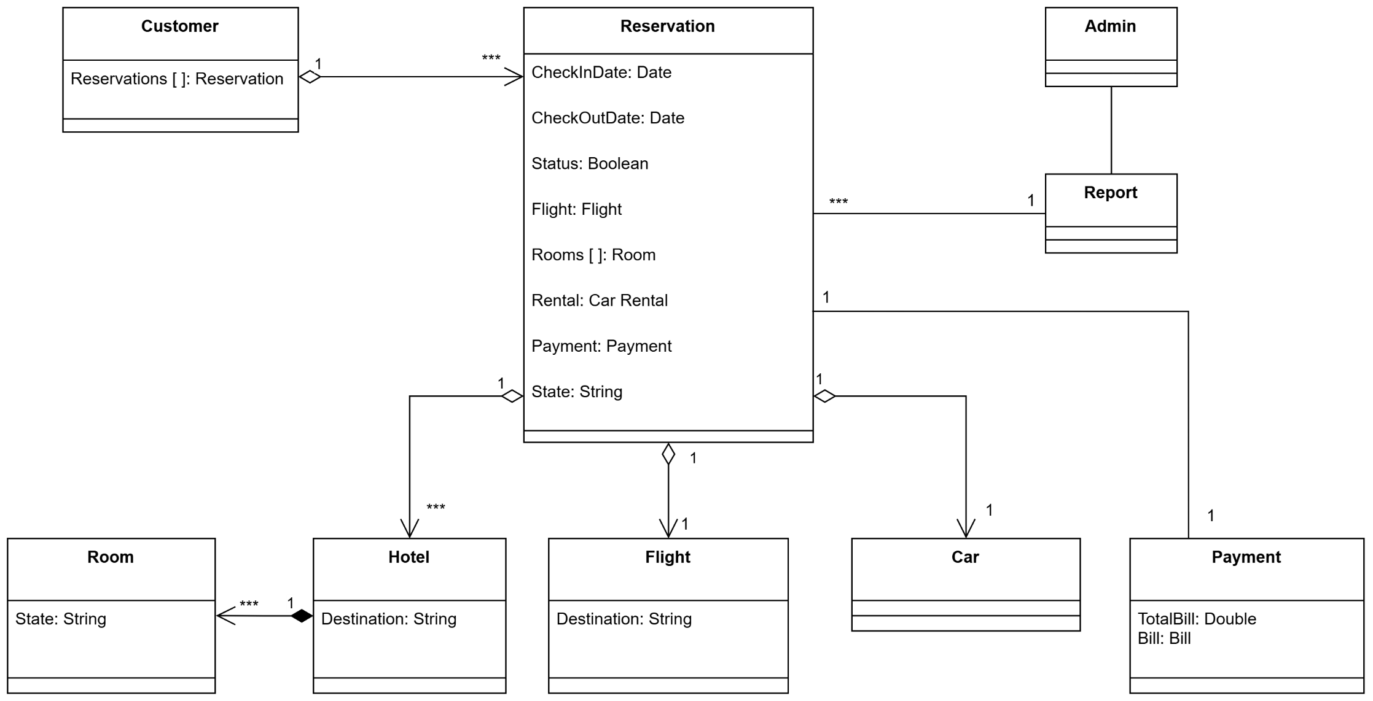
7.2 Initial Class Diagram
7.2 Initial Class Diagram

7.3 CRC Cards

8. State Diagram

9. Client-Object Relation Diagram

10. Class Diagram

11. Architectural Model
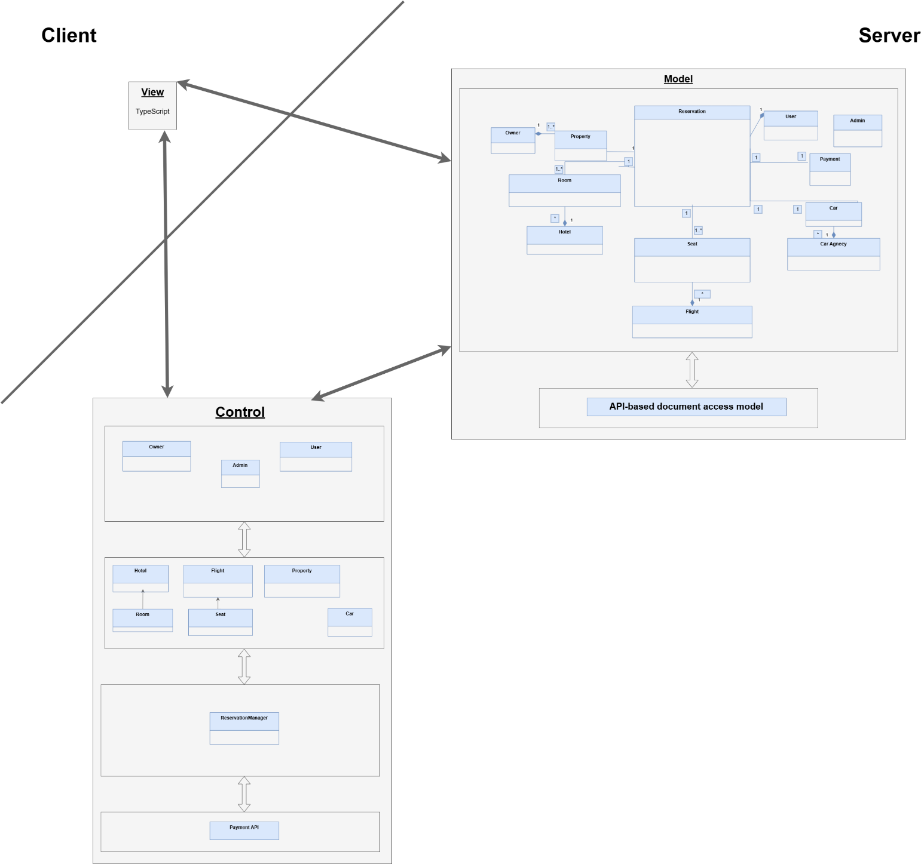
The system is a client–server-based system, following the Model–View–Controller (MVC) architectural pattern to ensure separation of concerns, scalability, and maintainability.
The client side is responsible for user interaction and presentation, while the server side handles business logic, data management, and integration with external services such as payment processing.
1. Architectural Description
1.1 Client Side
The client is implemented as a TypeScript-based application, acting as the presentation layer. It provides user interfaces for different roles, including User, Owner, and Admin.
Responsibilities of the client include:
- Displaying data retrieved from the server
- Collecting user inputs for reservations, payments, and management actions
- Sending requests to the server via controllers
- Rendering responses received from the server in an appropriate user-friendly format
The client does not contain business logic; instead, it communicates with the server through well-defined APIs.
1.2 Server Side
The server hosts the core system logic and is divided into Controller and Model layers.
1.2.1 Control Layer
The controller layer acts as an intermediary between the client and the model. It processes incoming requests, validates inputs, and coordinates system operations.
It includes:
- Role-based controllers for User, Owner, and Admin
- Domain controllers for managing Hotels, Rooms, Flights, Seats, Properties, and Cars
- A Reservation Manager component that handles reservation workflows
- Integration with an external Payment API to process transactions
Controllers ensure that client requests are translated into appropriate operations on the model layer.
1.2.2 Model Layer
The model layer represents the system’s data and business entities. It includes core entities such as:
- User, Admin, and Owner
- Reservation
- Hotel, Room, Property
- Flight and Seat
- Car and Car Agency
- Payment
Relationships between entities are defined to support complex reservation scenarios, such as booking multiple services under a single reservation.
The model layer is responsible for:
- Enforcing business rules
- Managing data consistency
- Interacting with the underlying data storage using an API-based document access model
2. Data Access and Integration
The system uses an API-based document access model to store and retrieve data.
External services, such as payment processing systems, are accessed through secure APIs, ensuring reliable and safe transaction handling.

12. Component Diagram

13. Project Estimated Cost
- User Inputs:
1. Reserve property
2. Sign up
3. Login
4. Update profile
5. Book hotel (creates booking record)
6. Book flight (creates booking record)
7. Rent car (creates booking record)
8. Pay (payment request → interacts with payment gateway)
9. Review booking (create review)
10. Modify flights
11. Modify hotels
12. Modify cars
13. Add property
14. Delete property
15. Manage users
- Output:
1 Booking confirmation (hotel / flight / car)
2 Payment receipt
3 Invoice / transaction summary
4 Admin reports (users, bookings, revenue)
5 Owner report
6 System notifications (email / in-app)
7 Booking modification confirmation
8 Cancellation confirmation
- User Inquiries:
1 View available hotels
2 View available flights
3 View available cars
4 View booking details
5 View payment history
6 Owner views users
7 Owner views properties
8 Search bookings
- External Interface Files:
1. payment gateway
2. authentication service
- Internal logical files:
User: Customer, Owner, Admin
Property: Property, Room, RoomType, Hotel
Booking: Reservation, Seat
Payment: Payment, Bill
Review: Reviews
Car: Car, CarAgency
Total ILFs = 6
Complexity levels were assigned by comparing the system with similar academic travel booking and reservation systems reported in software engineering literature, where most transactional functions are considered of average complexity.
- A) User Inputs (UI): 15 -> average: 15 x 4 = 60
- b) User Outputs: 8 -> average: 8 x 5 = 40
- C) User Inquiries: 4 -> average: 8 x 4 = 32
- D) Files: 6 (user: average, property: average, booking: complex, payment: average, review: simple, car: average), therefore assume average -> 6 x 10 = 60
- E) External Interfaces: 2 -> average: 2 x 7 = 14
UFC = 206
Factor-by-Factor Rating (Fi):
1. Backup and recovery:
Rating: 3 (Average)
2. Data communication
Rating: 3 (Average)
3. Distributed processing functions
Rating: 3 (Average)
4. Is performance critical?
Rating: 2 (Low)
5. Existing operating environment
Rating: 3 (Average)
6. On-line data entry
Rating: 4 (High)
7. Input transaction built over multiple screens
Rating: 3 (Average)
8. Master files updated on-line
Rating: 4 (High)
9. Complexity of inputs, outputs, files, inquiries
Rating: 3 (Average)
10. Complexity of processing
Rating: 3 (Average)
11. Code design for re-use
Rating: 2 (Low)
12. Are conversion/installation included in design?
Rating: 1 (Very low)
13. Multiple installations
Rating: 2 (Low)
14. Application designed to facilitate change by the user
Rating: 3 (Average)
Fi = 38
Complexity multiplier = 0.65 + (0.01*38) = 1.03
FP = UFC x Complexity Multiplier = 206 x 1.03 = 212

The general system characteristics were rated on a scale from 0 to 5 based on the system description. The total Fi value was 38, resulting in a complexity multiplier of 1.03. This slightly adjusted the Unadjusted Function Points.
Languages: NodeJS and Typescript, since both are JS-based, we can safely use:
AVC =50 LOC/FP
LOC = AVC * FP = 50 * 212 = 10600, KLOC = 10.6
Calculating M:
1. RCPX -> Rating: Nominal, Multiplier: 1.00 2. RUSE -> Rating: Nominal, Multiplier: 1.00 3. PDIF -> Rating: low, Multiplier: 0.95 4. PREX -> Rating: Nominal, Multiplier: 1.00 5. PERS -> Rating: Nominal, Multiplier: 1.00 6. SCED -> Rating: Nominal, Multiplier: 1.00 7. FCIL -> Rating: High, Multiplier: 0.9
Therefore M = 0.86
Effort multipliers were evaluated based on project characteristics. The system is a standard web-based application with moderate complexity and average team capability. Good development tools reduce effort slightly. The resulting effort multiplier M was estimated as 0.86.
b = 1.16
PM = A x Size^B x M = 2.94 x 10.6^1.16 x 0.86 = 40 person per month

14. Time Plan

15. References

16. Appendices

